RFID Hall Pass – Final Project

Christopher Yang, Lautaro Stamati

Week 2 – 4/25/2025

Executive Summary:

We’ve finalized the core code across four distinct versions, testing each multiple times. While we’ve made progress, reading and writing strings to the RFID cards remains unresolved.

The wiring has remained consistent throughout. On the code side, we're attempting to embed a string containing the tag’s UID, location, and other relevant data.

With the multi-device setup, one device will function as the "master", redirecting all signals to its serial output, while the other devices will act as detectors only. At this point, the main development is complete — the final step is enabling communication between the cards and the system.

Schematic:

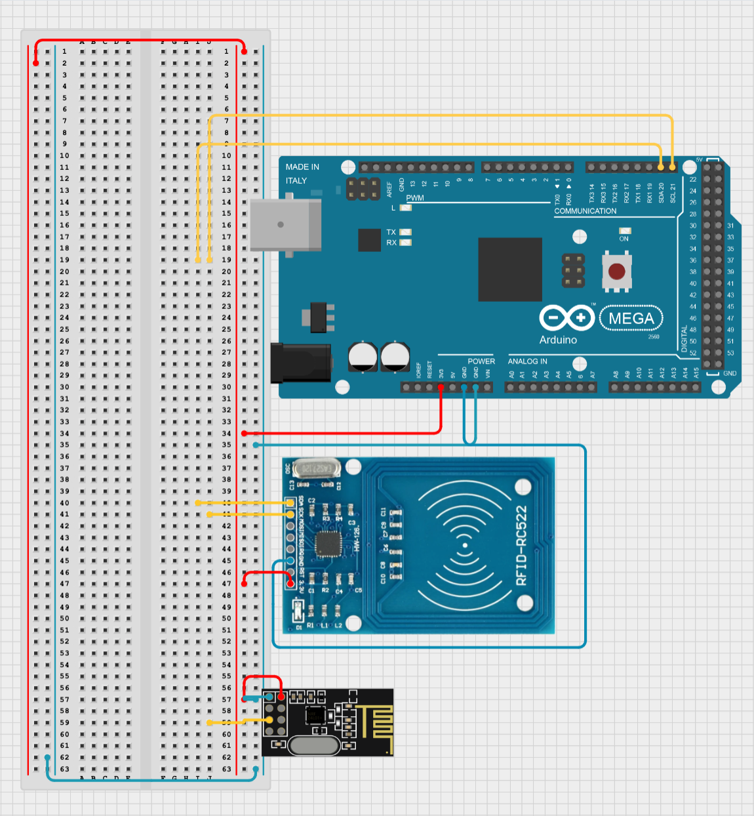

Gantt Chart & Planning:

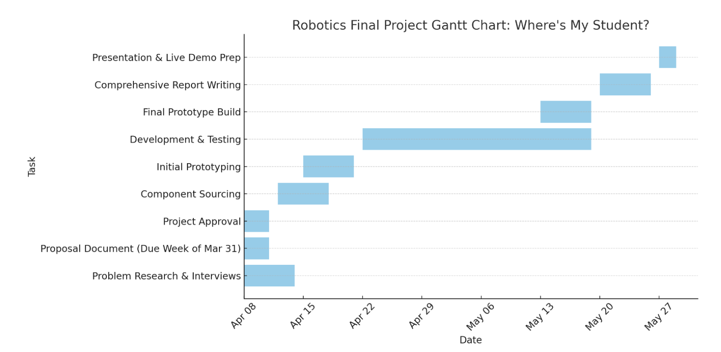

Next week, we’ll attempt to connect the data from one card with that of the other. Once that is done the next step will be to design the box that surrounds our device.